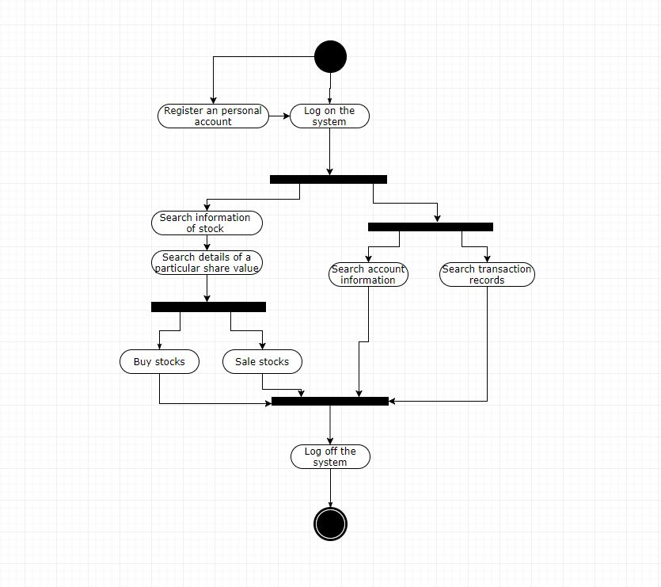**Activity Diagram - Gao Fei**